ECONOMICS MAJOR (link to university catalog)
NOTE: Use Degree Works for Progress
2023-24 Advisement /Planning Form

Student Name: |  |  |  | Grad QRTR
W Number: |  |  |  | Second MJR
EMAIL: |  |  |  | Meets 180 total credit requirement
 |  |  |  | Meets 60 Upper-Division Credits
REQUIRED COURSES: |  |  | Quarter or Grade  Advising Notes:  Electives: Take 32 credits under departmental advisement; at least 24 of these credits must be upper division credits in Economics; a minimum of 16 of the 24 credits of Economics electives must be at the 400 level; 8 credits can be within CBE.  Only 40-48 upper-division credits (depending on CBE electives) are built into the major. The university requires 60.  ❑ Take one Communication focus – Economics (CF-E) or a Communication Focus (CF) course.  Writing Proficiency Points (WP points) are built into this major  NOTE: ECON 309, ECON 446 & ECON 447 may not be counted toward this major.  *If you are planning on going to a graduate program, take MATH 124
DSCI 205 or MATH 240 or MATH 341 (4)
ECON 206 (4)
ECON 207 (4)
ECON 303 (4) [WP1]
ECON 306 (4)
ECON 307 (4)
ECON 375 (4)
MATH 124* (5) or MATH 157 (4) or equivalent
CSCI 101 (4) or MIS 220 (2)
Electives (4 credits each)
CBE Electives: |  | WP/CF-E | Quarter or Grade
300-400 Level ECON Electives: |  | WP/CF-E | Quarter or Grade
400-Level ECON Electives |  | WP/CF-E | Quarter or Grade
See the University Catalog for the Official Program of Study

Potential Economics Major Plan of Study
See advisor for assistance in planning your schedule

Academic Year:
FALL | CR | WINTER | CR | SPRING | CR | SUMMER | CR
Academic Year:
FALL | CR | WINTER | CR | SPRING | CR | SUMMER | CR

ECONOMICS MAJOR (66-69 credits)
Flow Chart

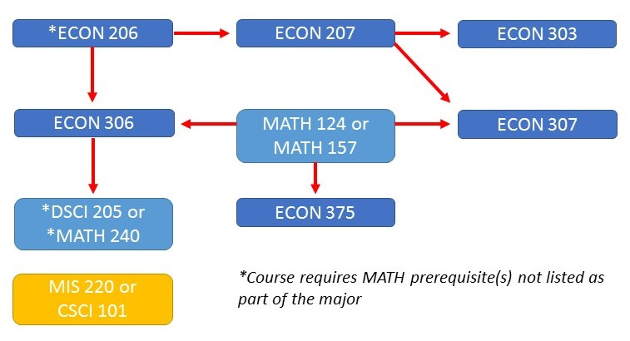

The university requires 60 upper-division credits, because this major only has 40 upper-division credits built into the curriculum, the space below is to assist you in tracking your total number of 300-400 level credits. Degree Works will also track the number of upper-division credits for you.

60 Credit Upper-Division Requirement | Credits
Those built into the major | 40
CBE Elective (if at 300-400 level)
CBE Elective (if at 300-400 level)
Total Upper Division Credits

ALSO – If you are planning on a master’s degree take calculus - MATH 124 not business calculus (157) and add MATH 125 to your planning. See the Department Canvas page for more helpful advising for Grad School.

