FINANCIAL ECONOMICS (link to university catalog)
NOTE: Use Degree Works for Progress
2022-23 Advisement / Planning Form
Student Name: |  |  | Grad QRTR
W Number: |  |  | Second MJR
EMAIL: |  |  | Meets 180 total credit requirement
Financial Assessment Exam:
*Accounting courses need to be taken sequentially
❑ Financial Economics majors are required to take an assessment exam prior to graduation. The test is provided at no charge. Students will be informed of the time and date of the examination. The examination requirement may be waived in the case of special circumstances by the Department Chair of Economics or Finance & Marketing or by the Dean of the College of Business and Economics.
The Communication Focus (CF) course and the three writing proficiency points are built into the major.
The required 60 upper-division credits are built into the major.

REQUIRED COURSES: |  | Quarter or Grade
ACCT 240 (4)
ACCT 245 (4)
ACCT 341* (4)
ACCT 342* (4)
DSCI 205 OR MATH 240 OF MATH 341 (4)
ECON 206 (4)
ECON 207 (4)
ECON 303 (4) [WP1]
ECON 306 (4)
ECON 307 (4)
ECON 375 (4)
FIN 341 (4) (requires MIS 220 as prereq)
FIN 440 (4) [WP1]
FIN 441 (4) [WP1]
FIN 444 (4) [WP1]
FIN 448 OR FIN 449 (4) [CF]
ACCT 343* OR ECON 411 (4)
MATH 124 OR MATH 157 or equivalent
MIS 220 or CSCI 101 (2 cr) |  | ❑ 12 credits of upper-division economics electives under departmental advisement; a minimum of 8 of these credits must be at the 400 level  ❑ 8 credits of upper-division finance electives under Professor Benson's advisement; a minimum of 4 of these credits must be at the 400 level
Upper-Division ECON Electives (12) |  | Quarter or Grade
Upper-Division Finance Electives (8) |  | Quarter or Grade

NOTE: ECON 309, ECON 311, ECON 446 and ECON 447 may not be counted towards this major.

Academic Year: Potential Plan of Study - See your advisor for assistance
FALL | CR | WINTER | CR | SPRING | CR | SUMMER | CR
Academic Year:
FALL | CR | WINTER | CR | SPRING | CR | SUMMER | CR

FINANCIAL ECONOMICS MAJOR
Flow Chart

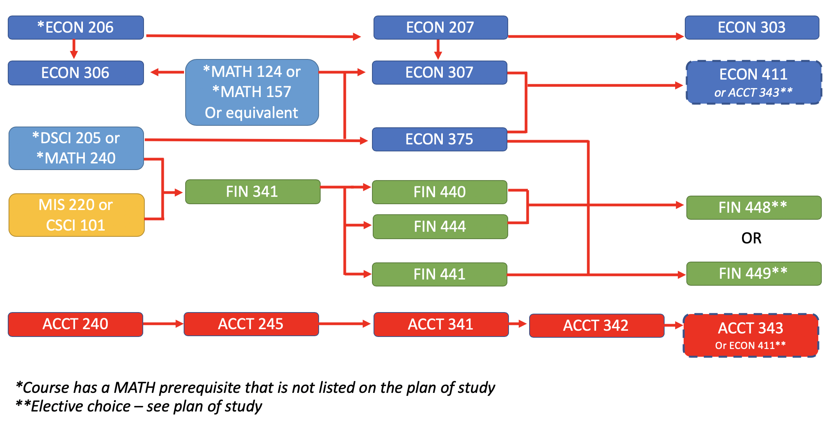
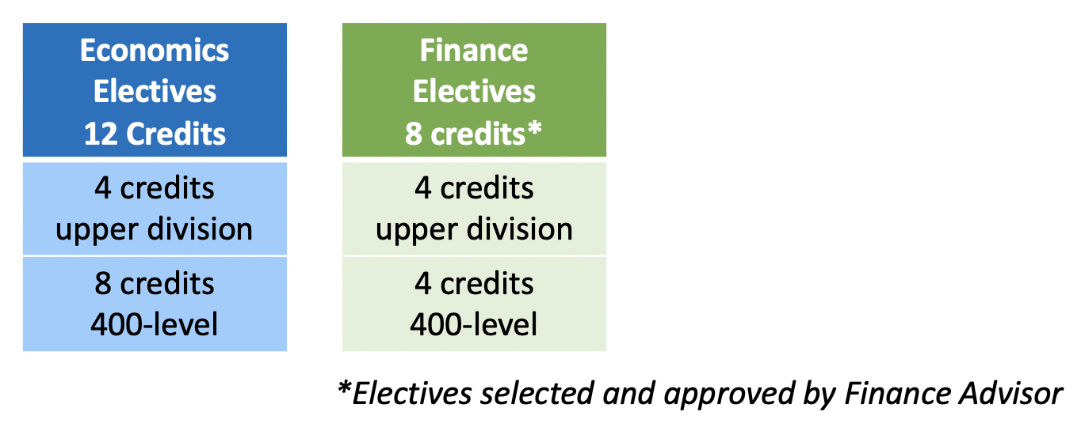

MINORS:
❑ The Financial Economics major has two minors that do not require many additional credits to complete.
❑ The Accounting minor: Take ACCT 343 as an elective plus one additional course - ACCT 331.
ECON 411 can be taken as an approved 400-level elective.
❑ The Business Administration minor: Take three additional courses: MGMT 271; MGMT 311 and MKTG 380
Minors can be declared using the Minor Declaration Form on the CBE Website.

