ECONOMICS MAJOR (link to university catalog)
NOTE: Use Degree Works for Progress
2022-23 Advisement /Planning Form

Student Name: |  |  |  | Grad QRTR
W Number: |  |  |  | Second MJR
EMAIL: |  |  |  | Meets 180 total credit requirement
 |  |  |  | Meets 60 Upper-Division Credits
REQUIRED COURSES: |  |  | Quarter or Grade  Advising Notes:  Electives: Take 32 credits under departmental advisement; at least 24 of these credits must be upper division credits in Economics; a minimum of 16 of the 24 credits of Economics electives must be at the 400 level; 8 credits can be within CBE.  Only 40-48 upper-division credits (depending on CBE electives) are built into the major. The university requires 60.  ❑ Take one Communication focus – Economics (CF-E) or a Communication Focus (CF) course.  Writing Proficiency Points (WP points) are built into this major  NOTE: ECON 309, ECON 446 & ECON 447 may not be counted toward this major.
DSCI 205 or MATH 240 or MATH 341 (4)
ECON 206 (4)
ECON 207 (4)
ECON 303 (4) [WP1]
ECON 306 (4)
ECON 307 (4)
ECON 375 (4)
MATH 124 (5) or MATH 157 (4) or equivalent
CSCI 101 (4) or MIS 220 (2)
Electives (4 credits each)
CBE Electives: |  | WP/CF-E | Quarter or Grade
300-400 Level ECON Electives: |  | WP/CF-E | Quarter or Grade
400-Level ECON Electives |  | WP/CF-E | Quarter or Grade
See the University Catalog for the Official Program of Study

Potential Economics Major Plan of Study
See advisor for assistance in planning your schedule

Academic Year:
FALL | CR | WINTER | CR | SPRING | CR | SUMMER | CR
Academic Year:
FALL | CR | WINTER | CR | SPRING | CR | SUMMER | CR

ECONOMICS MAJOR (66-69 credits)
Flow Chart

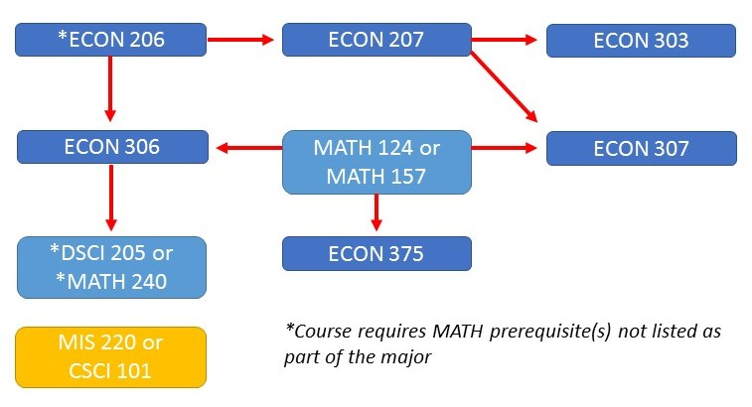

The university requires 60 upper-division credits, because this major only has 40 upper-division credits built into the curriculum, the space below is to assist you in tracking your total number of 300-400 level credits. Degree Works will also track the number of upper-division credits for you.

60 Credit Upper-Division Requirement | Credits
Those built into the major | 40
CBE Elective (if at 300-400 level)
CBE Elective (if at 300-400 level)
Total Upper Division Credits

