ECONOMICS /SOCIAL STUDIES MAJOR (link to university catalog)
NOTE: Use Degree Works for Progress
2021-22 Advisement /Planning Form
Student Name: |  |  |  | Grad QRTR
W Number: |  |  |  | Second MJR
EMAIL: |  |  |  | Met 180 total credit requirement
Met 60 Upper-Div. credit requirement
Only 33-37 Upper-Division Credits are built into this major unless Secondary Education Program is completed.
REQUIRED COURSES: |  |  | QRTR or Grade
DSCI 205 or MATH 240 or MATH 341 (4)
ECON 206 (4)
ECON 207 (4)
ECON 303 (4) WP1
ECON 306 (4)
ECON 307 (4)
ENVS 204 (4)
HIST 103 (5)
HIST 104 (5)
HIST 121 (5) |  |  | ❑ 16-20 credits of upper-division electives in economics under departmental advisement to complete the minimum required 90 credits for the major, at least 8 credits must be at the 400 level.  ❑ Take one Communication Focus - Economics (CF-E) course.  ❑ Take two additional WP points (need minimum of 3) taken within CBE  Note: ECON 309 may not be counted toward this major.
HIST 123 (5)
HIST 391 (5)
PLSC 250 (5)
MATH 124(5) or MATH 157(4) or equivalent
MIS 220 (2) or CSCI 101 (4)
ANTH 201; SOC 221 or 251 or 260 or 268 (5)
ENVS 221 or ENVS 240 (2-3)
16-20 Credits Upper-Division ECON |  | Credits | QRTR or Grade

Potential Plan of Study - See your advisor for assistance

Academic Year:
FALL | CR | WINTER | CR | SPRING | CR | SUMMER | CR
Academic Year:
FALL | CR | WINTER | CR | SPRING | CR | SUMMER | CR

ECONOMICS/SOCIAL STUDIES MAJOR
Flow Chart

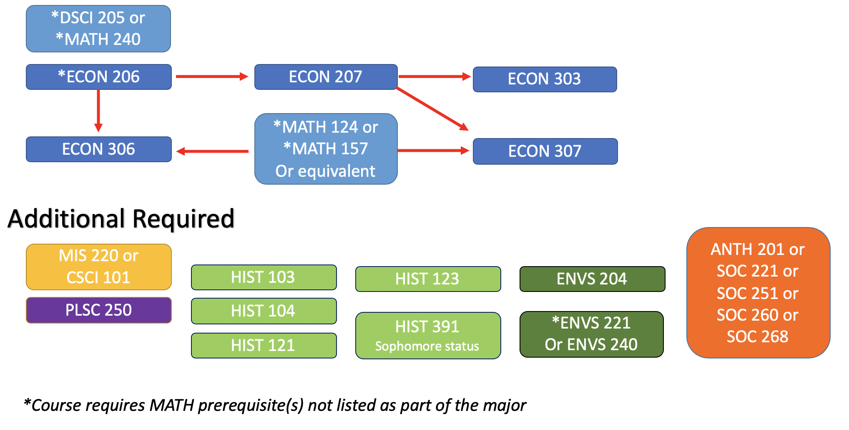

In order to receive a recommendation for State of Washington certification, students must complete the “teacher certification” program, including the content methods course SEC 426, which is offered by the Department of Secondary education as:
1) part of the undergraduate BA degree; or as
2) post-baccalaureate program, or as
3) part of the Masters in Teaching degree.

See the Secondary Education section of the catalog for program admission, completion, and teacher certification requirements. Completion of this major leads to an endorsement in social studies. Courses required for a state teaching endorsement must be completed with a grade of C (2.0) or better.

