ECONOMICS/MATHEMATICS MAJOR (link to university catalog)
NOTE: Use Degree Works for Progress
2023-24 Advisement /Planning Form
Student Name: |  |  |  | Grad QRTR
W Number: |  |  |  | Second MJR
EMAIL: |  |  |  | Meets 180 total credit requirement
REQUIRED COURSES: |  |  | Quarter or Grade | Meets 60 Upper-Division credit requirement
ECON 206 (4) |  |  |  | Only 56 upper-division credits are built in
ECON 207 (4) |  |  |  | Additional 4 credits Upper Division Required
ECON 303 (4) WP1 |  |  |  | Course: |  |  | Credits:
ECON 306 (4) |  |  |  | Course: | ADVISING NOTES: It is recommended to take MATH 204, MATH 304 & MATH 331 in successive quarters (in that order) and take MATH 224 before or concurrently with MATH 204.  Take MATH 341 & 342 (or 441 & 442) consecutively.  MATH 203 & 303 are currently not offered.  Note: MATH 101, MATH 112, MATH 114, MATH 115, MATH 118 and MATH 240, ECON 309, ECON 446 and ECON 447 may not be counted toward this major. |  | Credits:
ECON 307 (4)
ECON 475 (4)
MATH 124 & 125 or 134 & 135 or 138
MATH 204 & 331 (or MATH 203 & 303) (8)
MATH 224 (5)
MATH 225 (4)
MATH 226 (4)
MATH 304 (4)
M/CS 435 (4)
CSCI 140 or CSCI 141 or MATH 307 (4)
ECON 406 or ECON 407 (4)
MATH 341 & 342 or MATH 441 & 442 (8)
16 Upper-Division Credits ECON |  | Credits | Quarter or Grade
❑ 16 additional credits in upper-division courses in economics, under prior departmental advisement; 8 of these 16 credits must be at the 400 level
One elective needs the CF or CF-E attribute.

CF-E Course:

See the University Catalog for the Official Program of Study
Potential Economics/Mathematics Plan of Study
See advisor for assistance in planning your schedule

Academic Year:
FALL | CR | WINTER | CR | SPRING | CR | SUMMER | CR

Academic Year:
FALL | CR | WINTER | CR | SPRING | CR | SUMMER | CR

ECONOMICS/MATHEMATICS STUDIES MAJOR
Flow Charts

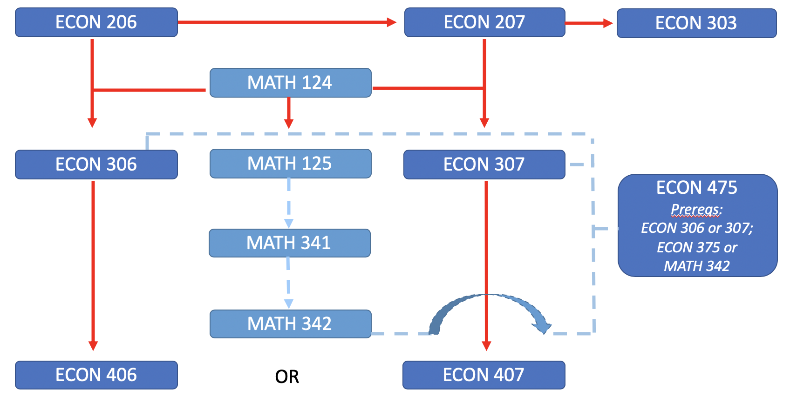

Computer Science Course Prerequisite:
CSCI 140 or CSCI 141 | MATH 112 or Equivalent

Mathematics Courses and Prerequisites beyond Calculus:
MATH 204 | MATH 125 or MATH 135 or MATH 138; MATH 224 recommended
MATH 224 | MATH 125 or MATH 135 or MATH138
MATH 225 | MATH 224
MATH 226 | MATH 125 or MATH 135 or MATH 138
MATH 304 | MATH 204, MATH 224
MATH 341 & MATH 342 | MATH 125 or MATH 135 or MATH 138
MATH 441 & MATH 442 | MATH 204, MATH 224, MATH 302 or MATH 309
MATH 331 | MATH 204, MATH 224 or concurrent
M/CS 435 | MATH 204; MATH 224; MATH 331; CSCI 140 or 141 or MATH 307
MATH 307 | MATH 125 or MATH 135 or MATH 138

